1. A. grep -n **“#**include**”** grep.c

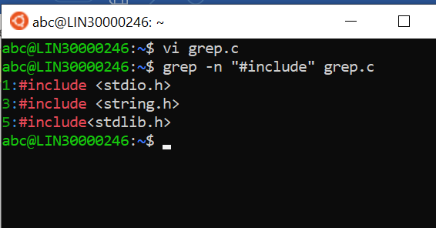

1. grep -v “#include” grep.c

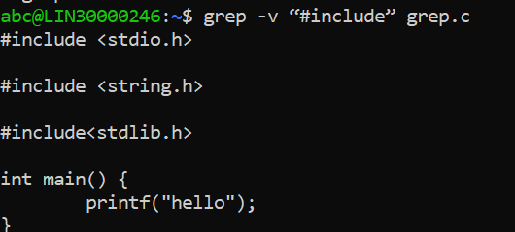

1. grep -n “main” grep.c

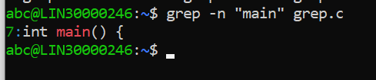

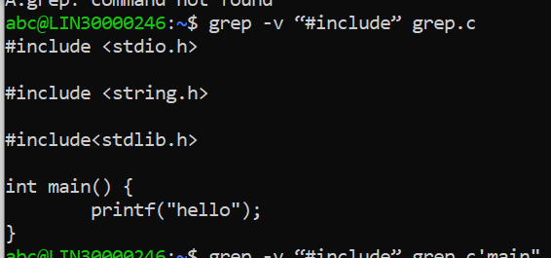

1. grep -n “[(*)$| {*}]” *.c

